Use Case Documents

Contents

UML System Use Case 2

UML Server Use Case 2

UML Client Use Case 2

UML Class Diagram 3

Server UML Class Diagram 3

Client UML Class Diagram 3

UML Sequence Diagram 4

Server UML Sequence Diagram 4

Client UML Sequence Diagram 4

UML State Diagram 5

Server UML State Diagram 5

User UML State Diagram 5

# UML System Use Case

## UML Server Use Case

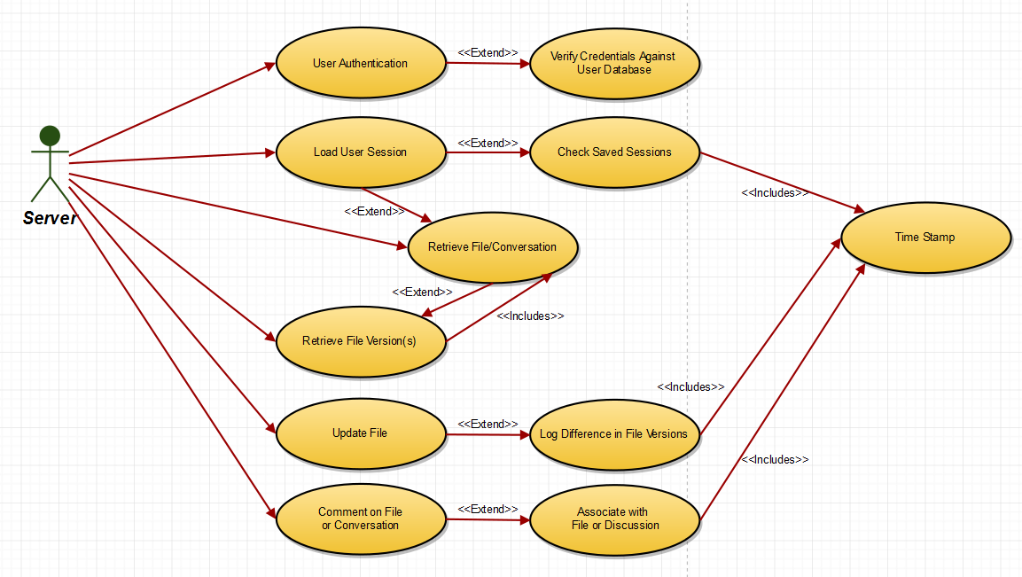

## UML Client Use Case

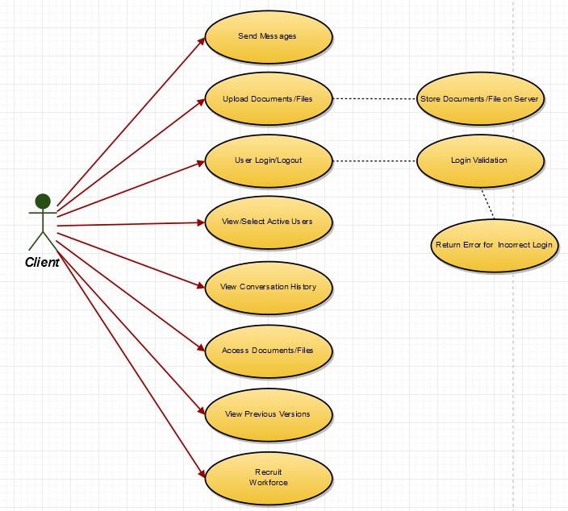

# UML Class Diagram

### Server UML Class Diagram

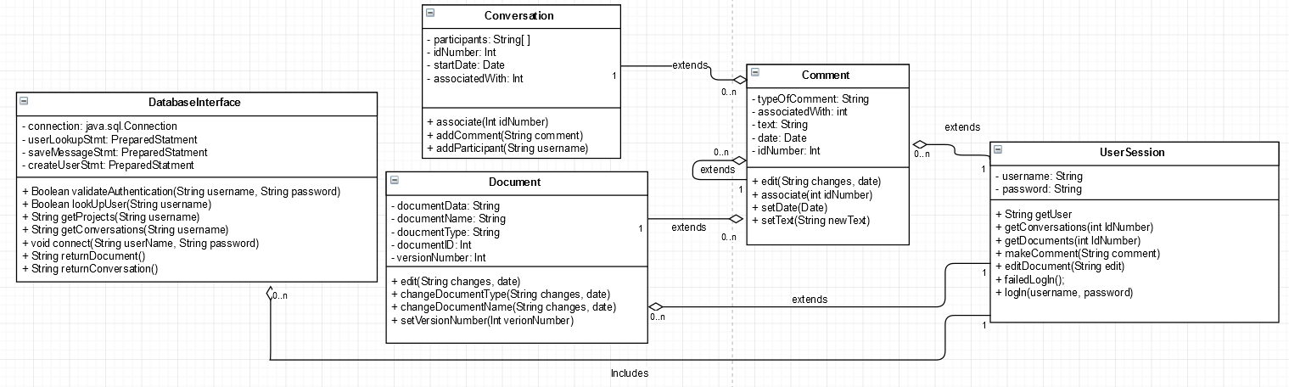

### Client UML Class Diagram

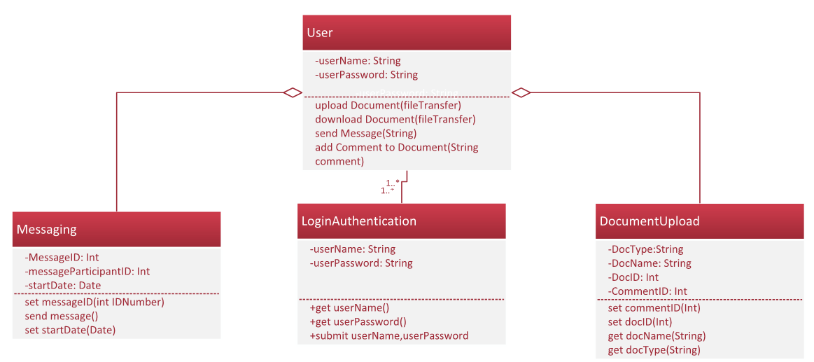

# UML Sequence Diagram

## Server UML Sequence Diagram

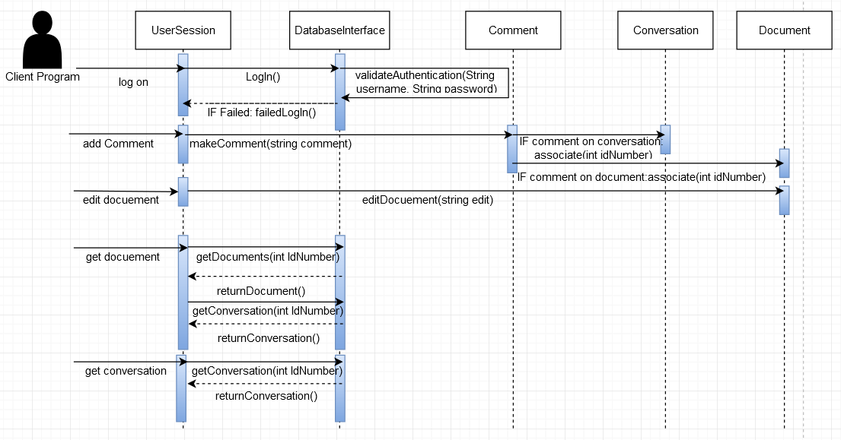

## 

## Client UML Sequence Diagram

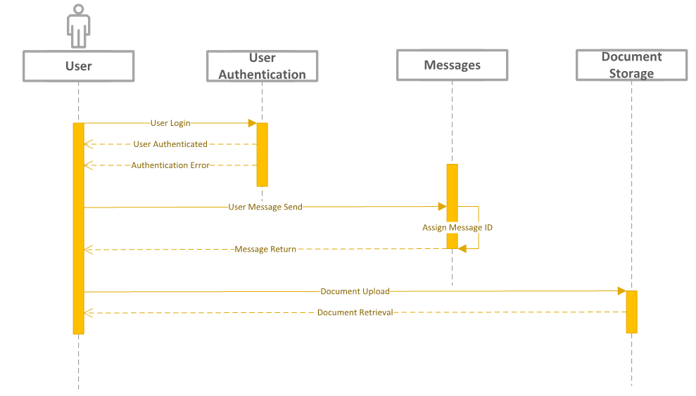

# UML State Diagram

## Server UML State Diagram

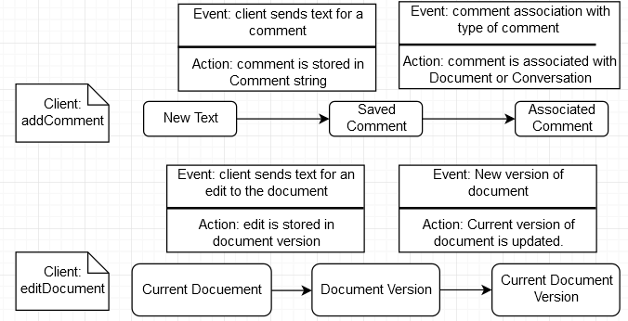

## User UML State Diagram

